Project Planning Phase
Project Planning Template (Product Backlog, Sprint Planning, Stories, Story points)

Date | 30 September 2026
Team ID | SWTID-2026-5468
Project Name | Implement Client Script & UI Policy (Incident)
Maximum Marks | 5 Marks

Product Backlog, Sprint Schedule, and Estimation (4 Marks)
Use the below template to create product backlog and sprint schedule
Sprint | Functional Requirement (Epic) | User Story Number | User Story / Task | Story Points | Priority | Team Members
Sprint-1 | High Impact Control (UI Policy) | USN-1 | As an administrator, I can create the UI Policy "High Impact Control" on the Incident table with the condition Impact is 1 - High. | 2 | High | Mershitha T
Sprint-1 |  | USN-2 | As an administrator, I can make Assignment group mandatory in the UI Policy and set Reverse if false, so the change is undone when Impact is not High. | 3 | High | Mershitha T
Sprint-1 | Urgency Control (UI Policy Action) | USN-3 | As an administrator, I can add a UI Policy Action that makes Urgency read-only when Impact is High. | 2 | High | Nimisha T
Sprint-1 | Auto Urgency (onChange Client Script) | USN-4 | As a user, when I set Impact to High, Urgency is set to High automatically and an info message is shown. | 3 | High | Nimisha T
Sprint-2 | Save Validation (onSubmit Client Script) | USN-5 | As a user, I am prevented from saving an Incident when Impact is High and Assigned To is empty. | 3 | High | Mershitha T
Sprint-2 | List Edit Restriction (onCellEdit Client Script) | USN-6 | As a user, I see an alert and the State value stays unchanged when I try to edit State directly in the list. | 2 | Medium | Nimisha T
Sprint-2 | Testing the Configuration | USN-7 | As a tester, I can verify that an Incident with High impact and empty Assigned To is not saved, and that it saves once Assigned To is filled. | 3 | High | Mershitha T, Nimisha T
Sprint-2 |  | USN-8 | As a tester, I can verify the reverse condition: changing Impact from High to Medium removes the restrictions and the record saves. | 2 | Medium | Mershitha T
Sprint-2 |  | USN-9 | As a tester, I can verify that State edits are blocked in the list but allowed from the Incident form. | 2 | Medium | Nimisha T

Project Tracker, Velocity & Burndown Chart: (4 Marks)
Sprint | Total Story Points | Duration | Sprint Start Date | Sprint End Date (Planned) | Story Points Completed (as on Planned End Date) | Sprint Release Date (Actual)
Sprint-1 | 10 | 6 Days | 14 Sep 2026 | 19 Sep 2026 | 10 | 19 Sep 2026
Sprint-2 | 12 | 6 Days | 21 Sep 2026 | 26 Sep 2026 | 12 | 26 Sep 2026

Velocity:
Imagine we have a 10-day sprint duration, and the velocity of the team is 20 (points per sprint). Let’s calculate the team’s average velocity (AV) per iteration unit (story points per day)

Total story points = 10 + 12 = 22 (Sprint-1 = 10, Sprint-2 = 12); number of sprints = 2
Velocity = Total story points completed / Number of sprints = 22 / 2 = 11 story points per sprint
Sprint duration = 6 days, so average velocity (AV) per day = 11 / 6 ≈ 1.83 story points per day

Burndown Chart:
A burn down chart is a graphical representation of work left to do versus time. It is often used in agile software development methodologies such as Scrum. However, burn down charts can be applied to any project containing measurable progress over time.
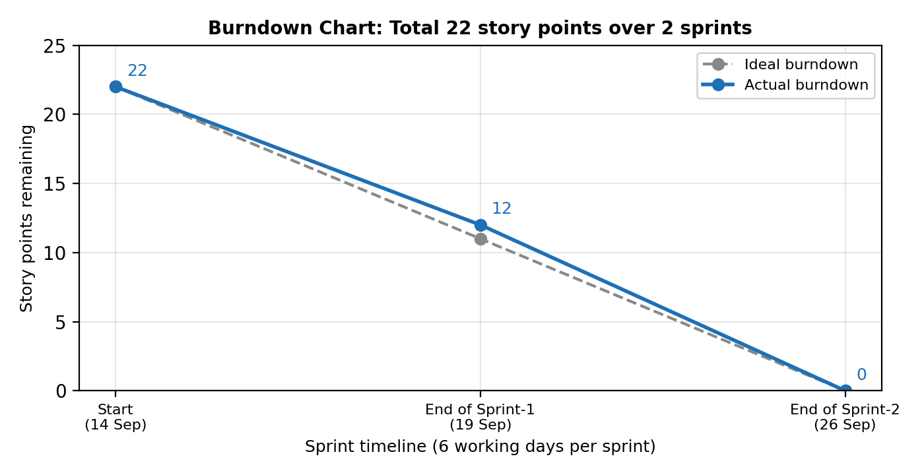
Burndown chart based on the story points planned and completed in each sprint (22 points in total).

https://www.visual-paradigm.com/scrum/scrum-burndown-chart/
https://www.atlassian.com/agile/tutorials/burndown-charts

Reference:
https://www.atlassian.com/agile/project-management
https://www.atlassian.com/agile/tutorials/how-to-do-scrum-with-jira-software
https://www.atlassian.com/agile/tutorials/epics
https://www.atlassian.com/agile/tutorials/sprints
https://www.atlassian.com/agile/project-management/estimation
https://www.atlassian.com/agile/tutorials/burndown-charts

